**Case Study – Bookshop Dataset**

This case study aims to study data modelling and data preparation for analysis. You have to understand the data model given in the diagram and create accordingly in Tableau after reading data from the datasets. Some questions and pointers are given as references. Based on the points, prepare data by - hiding unwanted fields, rename if needed, change default properties, etc.

After analyzing, you have to submit the tableau workbook, which contains the data model and a word document that explains your preliminary notes on the dataset. You can add as many points as you want beyond the given hints.

About the data set

Bookshop consists of 13 tables, combined in the following manner:

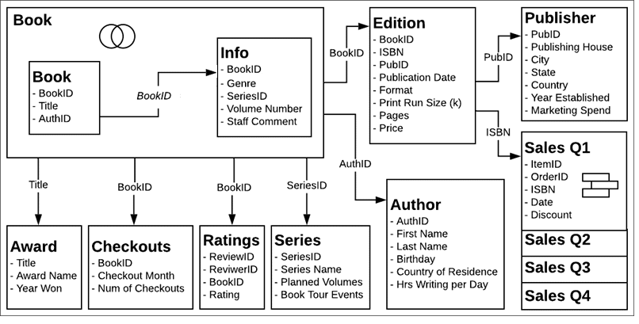

Based on the provided description, build a data model on the dataset. Perform preliminary data analysis using following pointers.

Q. Hide all the unwanted fields. (HINT - Any field ending with "ID" can be hidden)- Done

Q. Identify the most popular book titles based on the number of copies sold, review ratings? Which aggregation is most suitable for the 'ratings’ field? – Mallemaroking; Avg aggresion

Q. To which country do the most of authors belong?- United states

Q. Do some publishing houses seem to specialize in any way? (HINT - Take help of fields Publishing House, Format and Count)- pie chart (etaoin shrdlu press in usa has larget count sales)